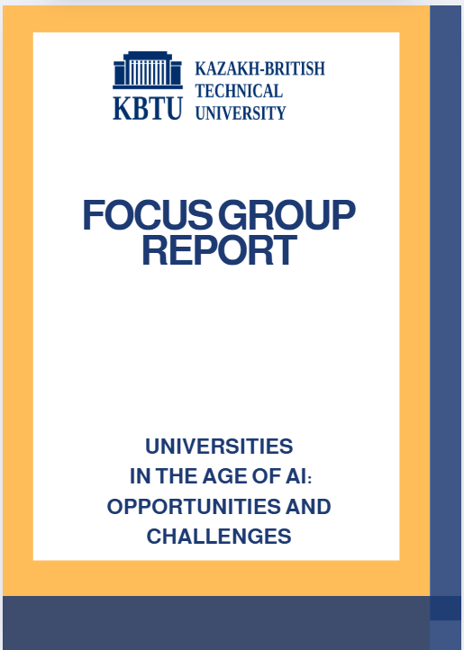
SUMMARY
This study examines how AI is changing modern university education, specifically student interactions with educational materials, familiar learning approaches, the skills most important in the digital age, and how students perceive its opportunities and risks. The study was conducted in a focus group format with 25 fourth-year students majoring in Data Science & Business Analytics. A Google online survey was also conducted to determine students' attitudes toward AI. The results showed that AI has already become an integral part of the educational process, saving time, helping students understand complex concepts better, and improving the quality of written work. However, students are concerned that they are becoming increasingly dependent on technology, thereby degrading their own heretical thinking, creativity, and independence. Students favored a hybrid learning format that combines traditional methods with AI. According to the results, men were more likely to mention the functional advantages of AI, while women spoke more about the ethical and social aspects of using new technologies. Also, they noted that professors should explain how to use AI effectively in the educational process rather than prohibiting it. Furthermore, participants emphasized that teachers and students need training courses about the use of artificial intelligence and training in the ethics of working with new technologies.
Based on the entire discussion, certain recommendations were formulated, including the active implementation of AI in the educational process while maintaining the key role of the teacher, the development of data protection and academic integrity rules, and the introduction of courses on digital literacy and AI ethics. Moreover, it is important to train teachers to work with new technologies and develop collaboration between universities, IT companies, and research centers. Overall, students perceive AI not as a threat, but as a partner that makes learning effective, flexible, and personalized.

Table of contents
Introduction 3
Methodology 4
Discussion process 4
Main results 5
Outcome 1: to understand how AI has changed the way students study or complete their academic work 5
Outcome 2: to explore how AI affects creativity and problem-solving 5
Outcome 3: to examine whether students are becoming too dependent on AI tools 6
Outcome 4: to identify preferences between AI-integrated and traditional teaching methods 7
Outcome 5: to understand how professors should use AI to make learning more interactive and relevant 7
Outcome 6: key human skills in the age of AI automation 8
Outcome 7: priority skills and areas of study at universities in the context of technology development 8
Outcome 8: Students' attitude to reducing the length of study at universities under the influence of AI 9
Outcome 9: what does it mean to be a “smart student" in the age of AI? 9
Survey results 10
Gender analysis of the perception of artificial intelligence in the educational environment 18
Analysis of the responses of male respondents 19
Analysis of female respondents' responses 21
Associations of students with artificial intelligence 21
Recommendations 22

Introduction
AI is actively entering the education field today, significantly influencing how student’s complete assignments and learn. Various AI programs are used to search for information, understand complex texts, and write effectively. The purpose of this study aims to understand how students use AI and the challenges and benefits they perceive. This study also explores how new technologies are changing the learning process at universities. Furthermore, the given paper examined the problem of dependence on new technologies and envisioned a university of the future where AI will be integrated into the educational process.
The project is devoted to the topic "Universities in the age of AI: opportunities and challenges". The session took place on October 7, 2025, in an offline format at the KBTU and lasted approximately 30 minutes. The goal of the discussion was to examine how AI influences student learning and their creativity, independence, and critical thinking skills. The challenges and opportunities arising from its implementation in the educational process were also considered. Furthermore, discussions were held regarding the future of the university based on AI technologies and the human skills that will remain important in the age of automation.

Methodology
The focus group involved 25 students, all fourth-year students majoring in Data Science & Business Analytics. These students actively use AI in their studies and research. Our discussion was planned in advance and included nine key questions on this topic. In addition, a Google-survey was also conducted to determine students' attitudes toward AI and their level of use. Then, an "associative technique" was used, in which participants wrote down three words associated with AI, revealing their emotional perception and symbolic meaning of the new technologies.

Discussion process
The discussion took place in an open and welcoming atmosphere, allowing participants to express their opinions and share various insights and personal experiences. Moderators ensured the participation of all students, taking turns asking questions and facilitating discussion. Focus group participants were actively engaged in the process, providing real-life examples of their educational practices. They reflected on the ethical, professional, and creative aspects of using AI. It's worth noting that no serious difficulties arose during the discussion, although the students were initially hesitant. However, as the dialogue progressed, everyone became more relaxed, and the process became livelier. Key ideas were recorded by the moderators for further analysis.

Main results

Outcome 1: to understand how AI has changed the way students study or complete their academic work
Almost all participants agreed that artificial intelligence has significantly changed the learning process and habits. The majority reported using AI tools such as ChatGPT, Grammarly simplifies reading, explains complex concepts and improves the structure of written articles. Students describe artificial intelligence as a "learning partner". This saves time and increases productivity through quick access to information and clear interpretation. One participant said, " I had to read five articles to understand one topic. Now this is explained in a separate paragraph. "It helps to organize your thoughts when writing an essay," said another student.
However, some participants admitted that AI makes them too dependent or less inclined to critical thinking. "Sometimes I just accept the answer from AI, it is easy, but dangerous", the student admitted. In general, the discussion shows that students are aware of the risks of reducing interest in important sources and the uniqueness of opinion specimens, while also considering the capabilities of artificial intelligence to improve document efficiency and understanding.

Outcome 2: to explore how AI affects creativity and problem-solving
Students assessed the impact of AI on creativity and problem-solving in different ways. Many noted that AI’s creative potential is expanding, offering different perspectives, new ideas, promoting projects or essays. "Artificial intelligence helps if I have a creative crisis - it says what I can develop" said one of the participants. Another noted “The AI chat bot became very important because it represents steps that I am not thinking about”.
At the same time, several respondents noted that using a smartphone limits the user's capabilities. Someone pointed out that the phrases created by AI are monotonous, not diverse. As one participant noted "Sometimes it kills my creativity - everything starts to sound the same." . Everyone agrees that the impact of artificial intelligence on creativity depends on how students work: those who use it as a tool for developing mental abilities believe that it stimulates and those who hope for full-fledged answers limit their suggestions.

Outcome 3: to examine whether students are becoming too dependent on AI tools
Reactions on this issue were divided. Some students believed that they were becoming heavily dependent on artificial intelligence, while others argued that such tools were only part of the development of learning techniques. Those who were concerned said AI often replaces in-depth thinking, original writing and problem solving. One participant said "We rely too much on information technology and people don't even try to think more critically". Others fear that the availability of AI-generated content will lead to superficial understanding and even unintentional plagiarism.
On the other hand, some participants compared artificial intelligence to previous innovations such as calculators or Google searches, claiming that any new technology would be criticized at first, but would eventually become a scientific tool. “Artificial intelligence is similar to using Google".A student explained that it depends on how it's used. Another added that «the problem is not artificial intelligence, but that students forget to learn”. The discussion concluded that although dependency exists, it reflects a widespread shift in the way learners adapt to technologies rather than the global problem.

Outcome 4: to identify preferences between AI-integrated and traditional teaching methods
Most students like an integrated approach that combines AI teaching tools and traditional classroom learning. Some participants emphasized that artificial intelligence technology allows learning to participate, interact, and be more personal. And the teacher provides motivation, emotional connection and deeper understanding.As one student noted that "Teacher of artificial intelligence is useful. But I still need a true teacher to explain and motivate me”. “Another way of thinking seems outdated, while artificial intelligence makes things more interactive”.
However, many participants expressed doubts about automatic learning too claiming that it could make the education feel impersonal. One student said: “I want artificial intelligence to do exercises. But I want it to not replace human explanations". Overall, participants agreed that the best learning environment should combine the two components: using AI to support learning efficiency and professors to inspire critical thinking and human connection.

Outcome 5: to understand how professors should use AI to make learning more interactive and relevant
Almost all participants agreed that teachers should not avoid AI, but learn to use it tactically. Many students stressed that teachers should teach responsible use of AI, not just ban. One participant said, “Teachers should use artificial intelligence for practical testing and direct feedback”, while another added, “They should teach us how to check AI’s answers, not just copy them”.
Students also suggested that teachers could make lessons more dynamic by using AI-generated simulations, real-world problem scenarios and personalized learning materials. One respondent said, “When teachers show how AI is used in real work, lessons become more exciting”. Students generally believed that teachers who strategically integrated AI could create a more relevant and exciting study process.

Outcome 6: key human skills in the age of AI automation
As a result of the discussion, the students emphasized that human qualities which cannot be replaced by algorithms are beginning to play a key role in the conditions of fast automation and widespread adoption of artificial intelligence. In their opinion, it is these skills that determine the competitiveness of specialists in the future. Among the main participants, participants noted the importance of ability to communicate effectively and deliver results, critical and strategic thinking. Moreover, the role of ability to constantly learn and adapt, emotional intelligence, ethics and creative problem solving were discussed. According to the students, although technology can quickly process data and perform complex calculations, it can not replace human understanding of context, empathy, and the ability to inspire others. The participants said that although technology can quickly process data and perform complex calculations, it cannot replace a person's understanding of context, empathy, and the ability to inspire others.

Outcome 7: priority skills and areas of study at universities in the context of technology development
According to students, universities should train specialists who not only use technology but also understand how it works and what its consequences are. They believe that modern education should combine technical and humanitarian skills, mainly the ability to program and work with data, an understanding of how algorithms and automation operate, as well as the development of critical and analytical thinking. As one participant stated, "without knowledge of programming languages such as Python, it is impossible to truly understand how modern technical systems work." In addition, communication, teamwork, and ethics are important for the ability to simply explain complex topics and understand the limitations of using technology. The participants pointed out that it is important for universities to integrate theory with practical projects so that students can not only use AI, but also develop intelligent systems. "It's important not only to understand modern technology, but also to manage it and understand its limitations".

Outcome 8: Students' attitude to reducing the length of study at universities under the influence of AI.
Students have different attitudes towards the idea of reducing the university program from 3–5 to 1–2 years. Many people believe that "Two years is the best time: you can get the necessary skills and start working”. One participant added: "Spending five years in one profession is no longer so effective - AI is changing everything too fast”. But some students see the risk of a superficial education in this regard. According to them, "One year is not enough to understand the topic deeply and learn how to apply knowledge" emphasizes one of the participants. In general, most students agree that the two-year model is a definite compromise solution.

Outcome 9: what does it mean to be a “smart student" in the age of AI?
When discussing what it means to be smart today, whether technology knows how to write essays and solve problems, students demonstrated different positions. Many of them considered the question itself incorrect noting that artificial intelligence lacks imagination and understanding of the context. As one of the participants noted, “AI does not have intelligence - it only searches for and combines information”. Another added, “Intelligence is not about ready-made answers, but the ability to reason, doubt and explain why you think that way”. According to the participants, real intelligence does not manifest itself at the level of knowledge, but on the ability to use technology, analyze information and use it in a certain sense. One of the students emphasized that it is important not just to trust technology, but to be able to notice and analyze its mistakes: “The main thing is to understand where the system is wrong and why”. In conclusion, the participants highlighted that a smart student today is not a rival to artificial intelligence, but someone who knows how to competently interact with it. For them, intelligence lies in the ability to use technology consciously - as a means to deepen thinking rather than as a substitute for their own reasoning.

Survey results

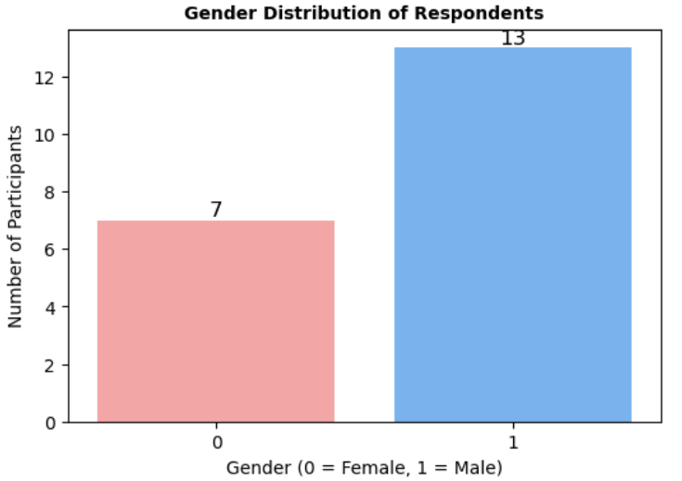
Picture 1
The Google form used for the survey included a question about the gender of the participants. According to the results shown in the diagram (Picture 1 ), 20 students participated in the study: 7 girls and 13 boys. Thus, the sample turned out to be slightly biased towards the male audience.
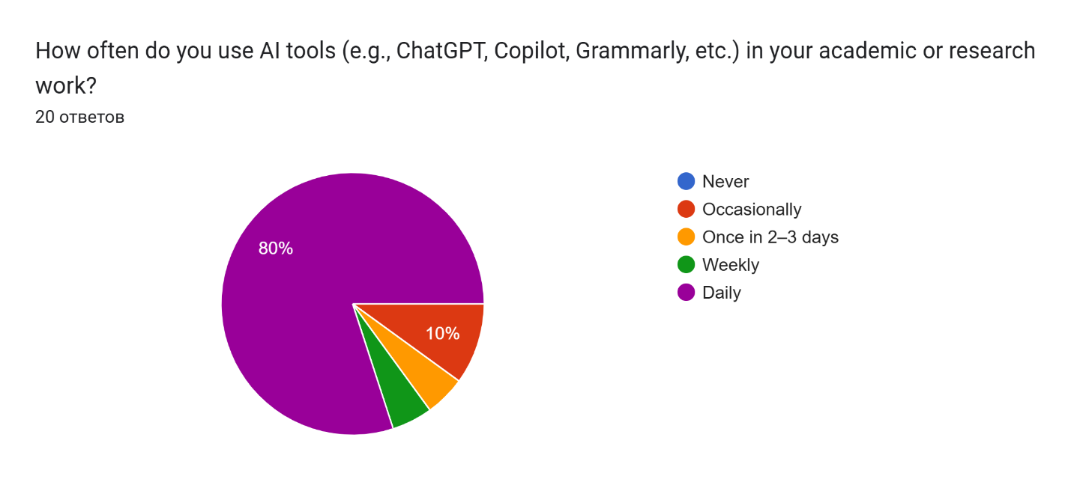
Picture 2
The results of the survey found that artificial intelligence had steadily entered the student's educational and research activities.As can be seen from figure (Picture 2), 80%of respondents use artificial intelligence on a daily basis, another 10% no participants report that they do not use such technology to fulfill their potential. This image reflects the high level of artificial intelligence integration in the study process.
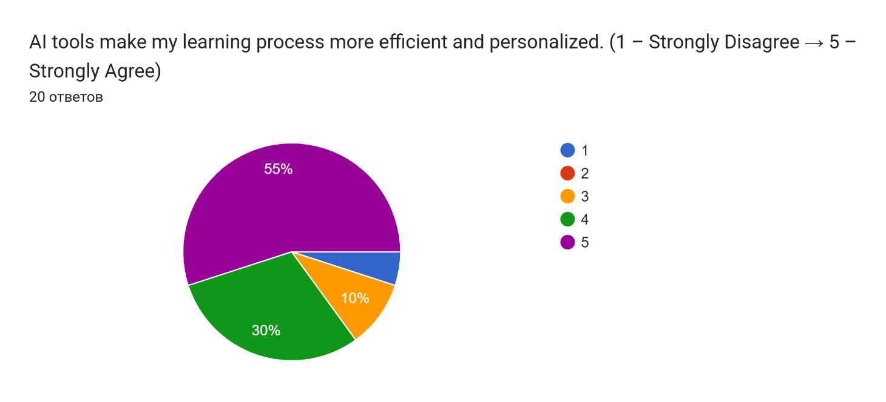
Picture 3
The figure (Picture 3) shows the results of a survey aimed at clarifying students' opinions on the impact of artificial intelligence technologies on the quality and personalization of learning. Data analysis shows the advantage of positive ratings: 55% of participants fully agreed that such technologies would make the learning process more efficient, and another 30% expressed partial agreement. About 10% took a neutral position and only 5% did not support this requirement. None of the respondents chose the option "totally disagree". Overall, 85% of students believe that artificial intelligence technologies make the learning process more flexible and efficient. Most revealed that the use of AI helps to find the necessary information faster, receive explanations corresponding to the level of training and build individual learning paths. The data obtained indicate a high level of confidence of students in artificial intelligence technologies and confirm their perception of artificial intelligence as a tool that promotes personalization and improves the quality of education.
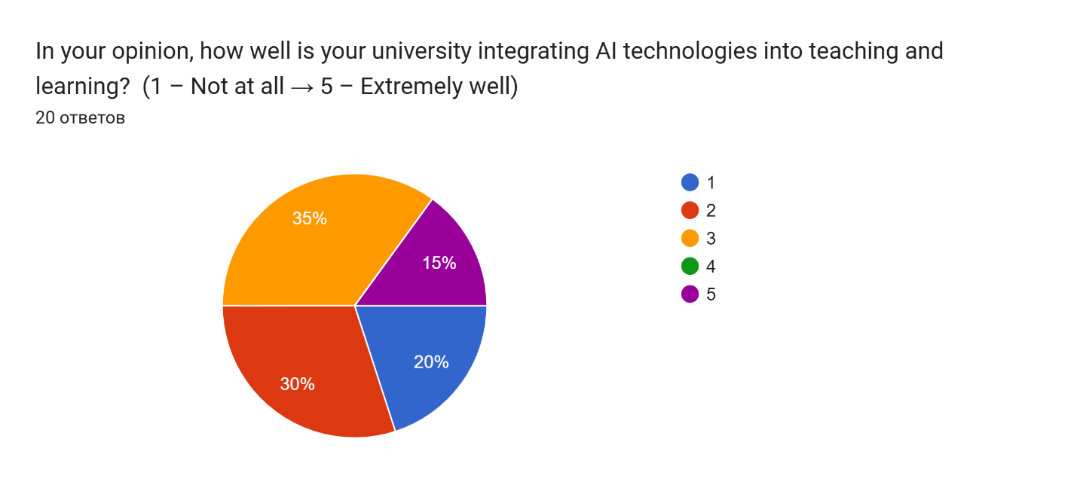
Picture 4
Picture 4 shows how students evaluate the implementation of artificial intelligence technologies in university education.The majority of respondents gave average ratings: 35% indicated the level of integration as moderate and 30% as below average. Only 15% believe that technology is being implemented very successfully, while 20% indicated weak integration. In general, students have a positive attitude to the idea of using AI, but they note the lack of consistency and limited use of technology in the educational process.
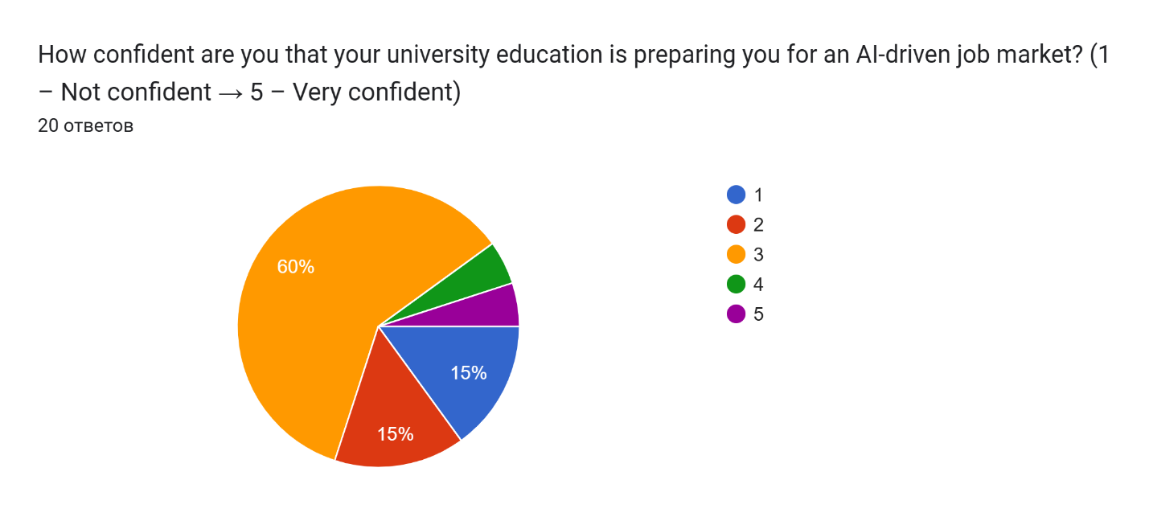
Picture 5
Picture 5 demonstrated how students assess how much the university really helps them prepare for the modern labor market where technology and automation are increasingly being used. The largest part of the participants, 60%, chose an average score of 3 out of 5, which indicates a restrained confidence in their preparation. Grades of 1 and 2 were given by 15% of respondents, while only 10% of the students said they felt confident (grades 4–5). Although interest in digital skills is growing, many students still lack confidence that university education provides them with real tools to work in a technological environment.
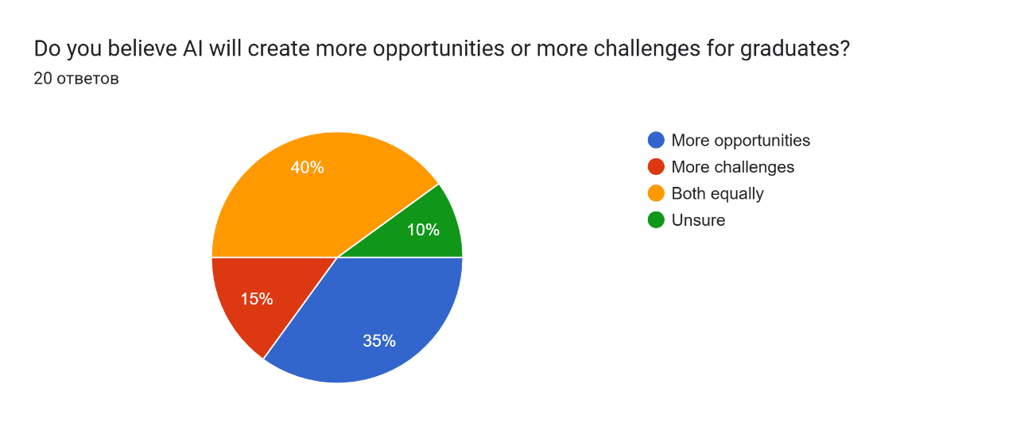
Picture 6
This given figure (Picture 6) shows how students assess the impact of artificial intelligence on the future career prospects of graduates. Opinions were quite diverse. The majority of respondents (40%) believe that technology will bring both new opportunities and certain difficulties, while 35% see them primarily as a potential for growth and professional development. For 15% of students, technology is more associated with risks and challenges. 10% of the participants could not respond. It can be indicated that students perceive artificial intelligence ambiguously. Some are associated with the opening up of career opportunities, while others are associated with the threats associated with automation and growing competition in the labor market.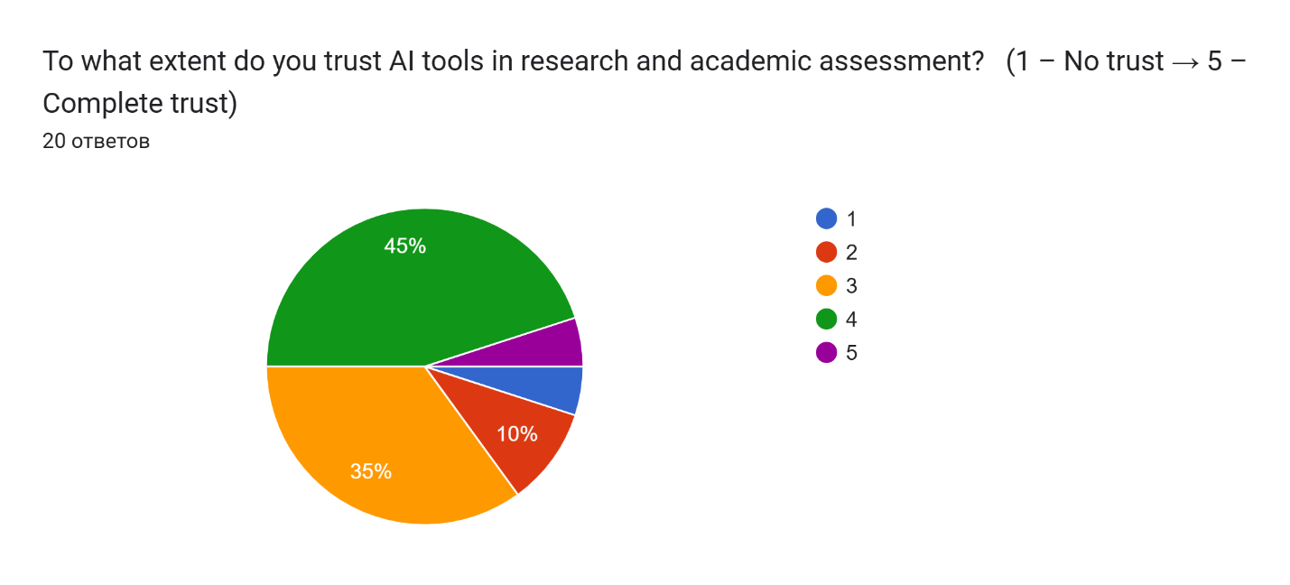
Picture 7

The picture 7 revealed the distribution of student responses regarding trust in artificial intelligence tools used in research and educational activities.45% demonstrated a high level of trust (score 4), while 35% chose a moderate level. Only 10% of the students expressed low trust (score 2) and 5% responded with a complete lack of trust (score 1). A small part fully trusts AI (score 5). Generally, students trust artificial intelligence technologies, but remain cautious and critical of their use in academic assessments and research.
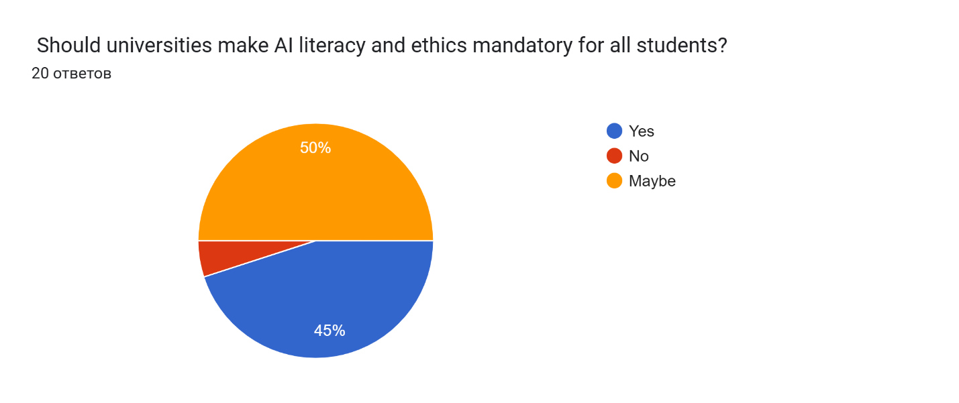
Picture 8
According to picture 8, the student responses regarding learning the principles of artificial intelligence and digital ethics were considered. The question was whether it should be mandatory for all students. The "Maybe" option was chosen by half of the students reflecting uncertainty and the need for additional information about the format of such training. 45% supported the idea of a compulsory course and only 5% opposed it. The results show that most students recognize the importance of building basic knowledge about AI and the ethical principles of its use. However, they expect a flexible approach to the implementation of such disciplines in the curriculum.
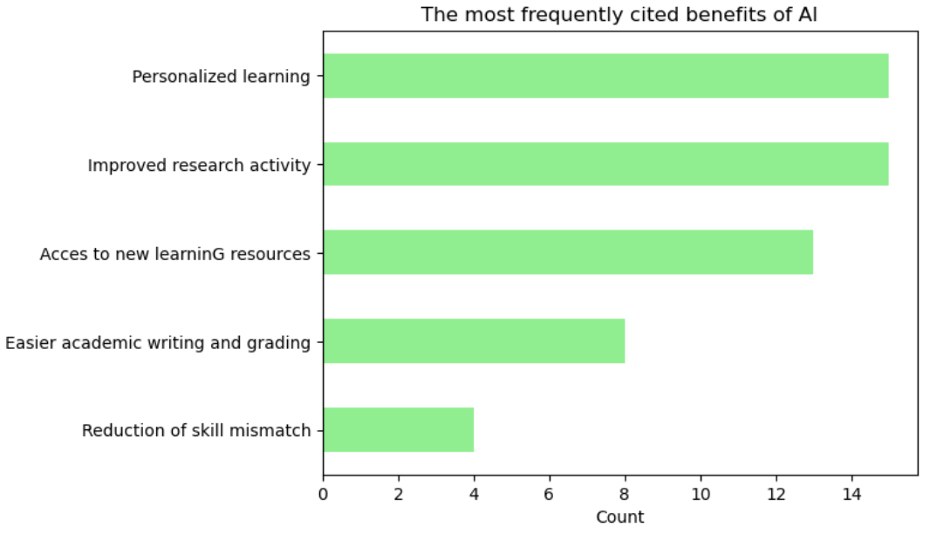
Picture 9
The figure shows the distribution of the most frequently mentioned advantages of using artificial intelligence in learning (Picture 9). In the first place is personalized learning and increased research activity (15 mentions each). This is followed by access to new learning resources (13 mentions), easier academic writing and assessment (8) and reduction of skills mismatch with labor market requirements (4). It can be demonstrated that students mostly see the value of AI in individualizing learning and supporting research activities.
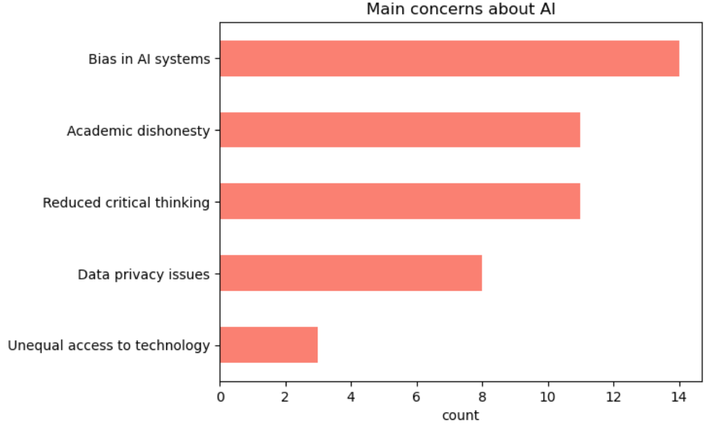
Picture 10
Picture 10 revealed the main concerns of students regarding the use of AI in education. The most frequently mentioned problems are bias in AI systems (15 mentions), then academic dishonesty (11) and decreased critical thinking (11).Less significant were issues of data privacy (8) and unequal access to technology (3).In summary, students are primarily concerned about ethical risks and the quality of learning, emphasizing the need for control, transparency, and responsible use of AI in the educational environment.

“In one sentence, how do you imagine the “AI-powered university” of the future? “
The students answered this question in different ways. Some of the participants admitted that they find it difficult to imagine such a concept or are skeptical about it. However, most describe the university of the future as a technological, automated and personalized learning space where digital systems help each student develop an individual trajectory. The responses often included ideas like "a university run by robots" or "a smart, adaptive, data-driven system." At the same time, some participants emphasized that technology should be combined with ethics and traditional values of education. In general, students see the AI-powered university as a modern and flexible educational ecosystem where artificial intelligence increases the efficiency and accessibility of learning, while remaining a tool rather than a substitute for human participation.

Gender analysis of the perception of artificial intelligence in the educational environment
Pictures 11 and 12 reflect how men and women evaluate the use of artificial intelligence in the educational process. This shows how often they use technology and trust it.As well as the extent to which they consider them useful for teaching and research, analyzing potential risks. In general, both men and women have a positive attitude towards the use of AI in education. Most people believe that technology helps students learn more effectively, makes it easier to write and review papers, opens up access to new sources of knowledge and supports research activity. At the same time, you can notice differences in accents. Men are more likely to talk about the functional benefits and convenience of tools, while women pay more attention to the social and ethical aspects of their use.

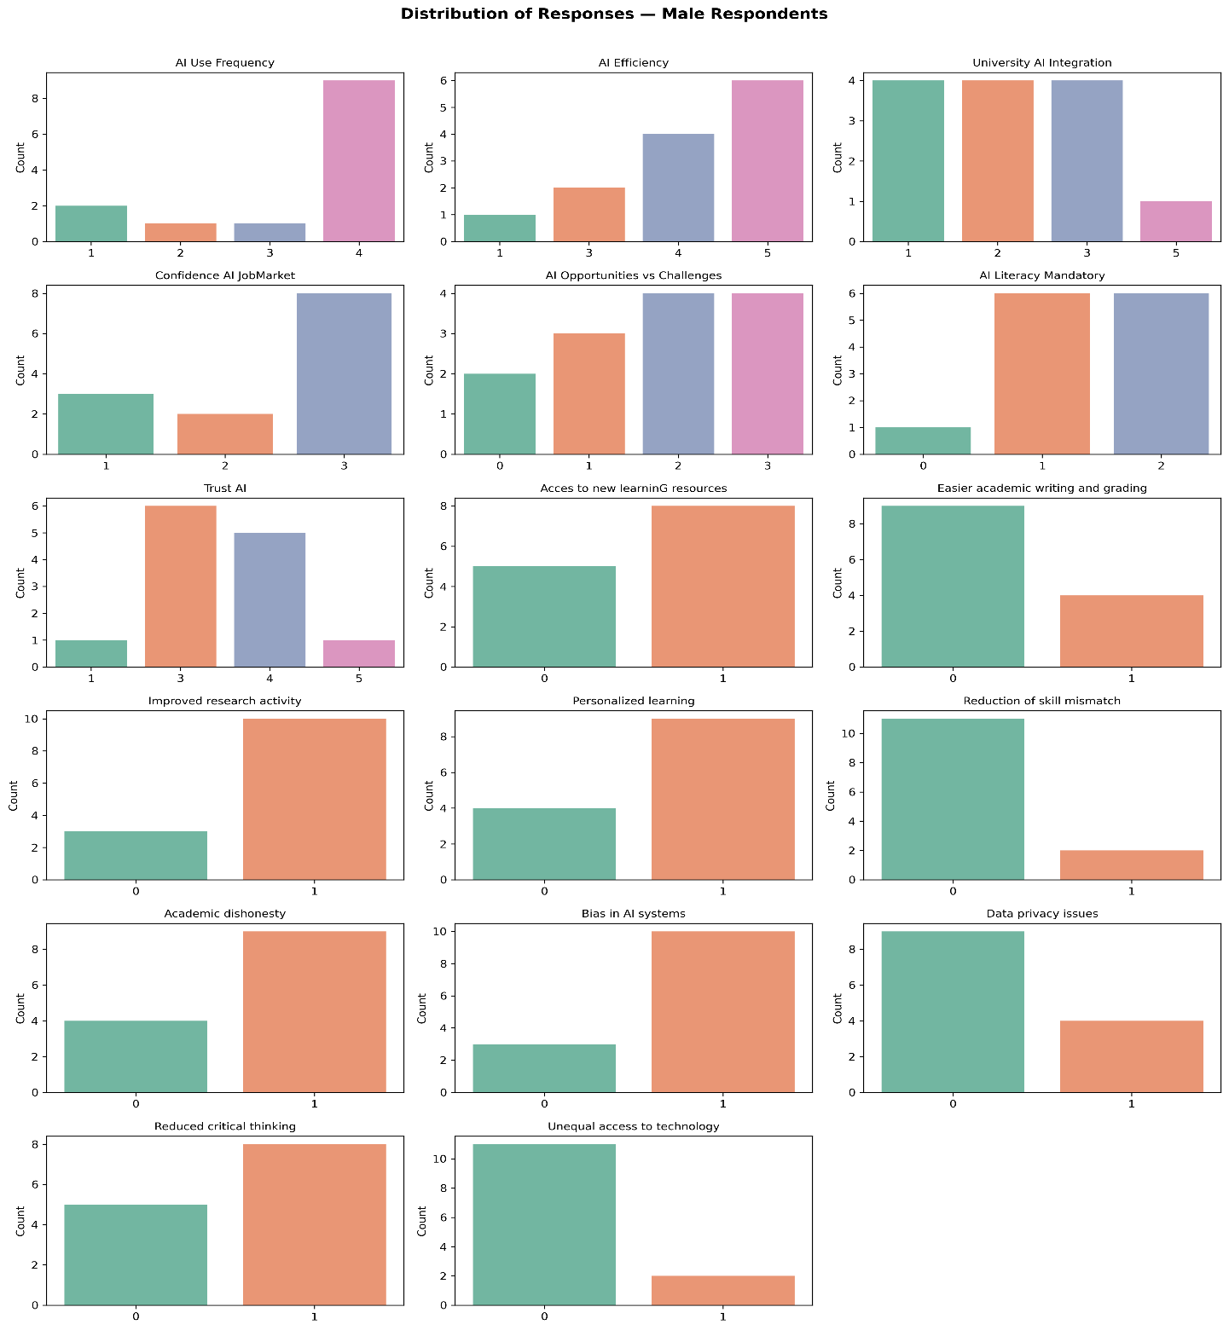
Picture 11

Analysis of the responses of male respondents
Most of the men who participated in the survey actively use artificial intelligence technologies in their studies. Most of them rated the effectiveness of such tools highly, by 4–5 points. Many think that AI has become a familiar part of the learning process. They use it to generate ideas, analyze data, and write texts. Men say that technology helps to complete tasks faster, simplify research work and provide access to more educational materials. The level of trust in AI remains moderate. Students recognize its benefits, but treat it with caution, especially when talking about the future labor market. They believe that the development of technology and decisions should be made by people, not algorithms. In addition, men are more likely to express concern about the unfair use of AI in their studies. There is a decrease in critical thinking and the leakage of personal data. Overall, their position can be described as pragmatic. They see the benefits of technology, but do not ignore the possible risks.

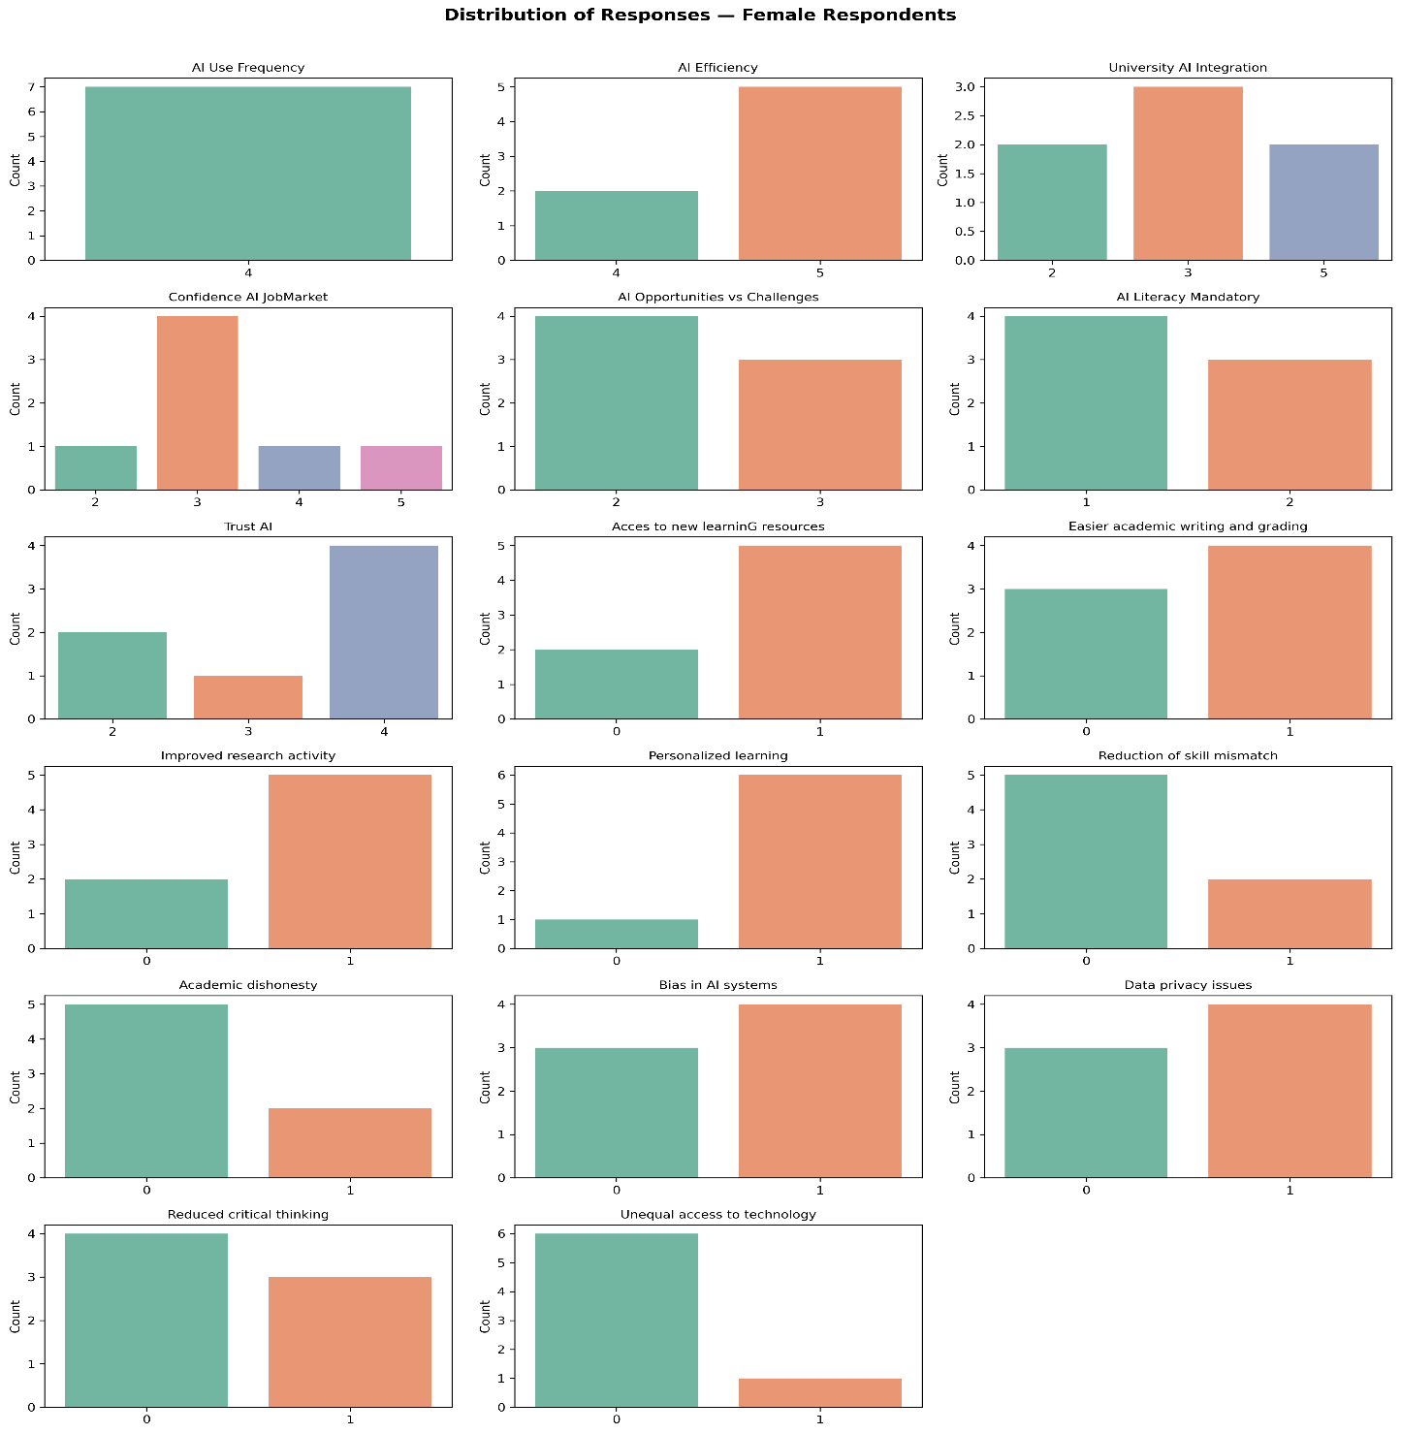
Picture 12

Analysis of female respondents' responses
The women who took part in the survey showed a high interest in using artificial intelligence technologies. Approximately 70% said they regularly use them in their studies. The majority (80%) rated the effectiveness of such tools by 4–5 points describing how they make the learning process more convenient, flexible and accessible. It was obtained that girls were more likely than boys to pay attention to social and ethical aspects. For example, algorithm bias, unequal access to technology, and the risk that people will think less for themselves. The importance for them include not only to be able to use AI, but also to understand how to use it responsibly and honestly. Despite caution, most believe that technology helps improve research, make learning more personalized and better prepare for the demands of the labor market. To conclude, men and women have a positive attitude towards artificial intelligence. The only difference is that men see it as a way to increase efficiency, while women see it as a tool that requires an informed and ethical approach. Representatives of both sexes note the risks associated with unfair use, loss of critical thinking and threat to privacy. In general, students view artificial intelligence not as a threat, but as an important part of the future of education, where technology and people must work together.

Associations of students with artificial intelligence
The association technique was used during the discussion.The students wrote down three words that they associate with artificial intelligence.
The most common concepts were “future”, “technology”, “success”, “help”, “study”, “fast”, which indicates the perception of AI as a symbol of progress, speed and effectiveness of learning.Along with this, words like “cheating”, “contradiction”, “unreliable” appeared, reflecting doubts and a cautious attitude towards technology.In general, the associations show that students see AI as an integral part of the future, but recognize the need for ethics, critical thinking, and responsible use.

Recommendations
Based on the results of the focus group and Google survey, a number of recommendations for improving teaching using artificial intelligence can be identified. According the discussion, the results showed that the integration of AI into the educational process at universities should be more proactive. It is essential to understand the nature of technologies rather than relying solely on their use in order to be aware of potential risks. The best approach is to integrate proven teaching methods with AI where AI serves as a support tool for the teacher without replacing their role. This will make the learning process more engaging, adaptive and convenient for every student. It is essential to ensure that all students have equal opportunities to use modern electronic tools.AI can be a valuable assistant for teachers freeing up time for more important tasks. The use of artificial intelligence should go hand in hand with the development of critical thinking and independence in students. It is important for educators not to ban AI, but to explain how to use it correctly and responsibly. Students should be able to verify the information they receive, avoid plagiarism, and remember that AI is an assistant, not a replacement for their own efforts. It can help with ideas and inspiration, but analysis and thinking must be done independently. As technologies evolve, human skills such as creativity, critical thinking, communication, and teamwork become especially important. These are the qualities that distinguish humans from machines and will be in demand in the future. For the integration of AI into education to be successful, universities and government organizations need to develop rules and standards that protect student data and maintain academic integrity. Furthermore, mandatory courses on digital literacy and AI ethics should be introduced as a required course, as this will help students understand how algorithms work and their limitations. In addition, students will be able to use them safely and effectively. It's also important to continually improve the skills of faculty in AI, training them in methods for integrating AI into the educational process. Finally, partnerships between universities, companies, and research centers should be developed so that students can participate in the creation and testing of new, relevant solutions, not just the use of AI.

